Jewish Music
Two Part Lecture
University of Kansas
Sept 2, 2010

Hazzan Rob Menes
Congregation Beth Shalom

Brief Outline

1. What is Jewish Music?
2. What is the history of Jewish Music?
3. What are the melodic, harmonic, and rhythmic elements of Jewish Music?

Jewish Music is:

Music that is used in the performance of tefillah (prayer), life cycle events, and community celebration/commemoration.

Books to Note

Idelsohn, A.Z. Jewish Music – Its Historical Development
Idelsohn, A.Z. Thesaurus of Hebrew Melodies Vol 8
Eisenstein, J.K. Jewish Music
Kalib, S. The Musical Tradition of the Eastern European Synagogue
Levine, Joseph A. Synagogue Song in America
Jacobson, J. Chanting the Hebrew Bible
Binder, A.W. Biblical Chant

II. Theoretical Concepts in Jewish Music

Biblical Chant
Masoretic notation
Trope system tetrachords
Psalmody
Textual dominance
Nigunim
Melodic dominance
Modes
Adoshem Malach
Magen Avot
Ahavah Rabbah

Improvisation
Motifs
- Biblical Chant:

- Torah (first 5 books of the Bible) and Haftarah (prophetic writings) are read aloud publicly each week (dating from Ezra, 4th cent BCE).
- Public reading must be chanted.
- Musical layer was an oral tradition, completely unwritten until 9th cent CE.
- Masoretes, in Tiberias, created notation for the musical layer along with a system for adding vowels.
- Torah is printed: by hand, one person working one year. No punctuation or vowels, but some paragraph breaks are defined. Only clear breaks are for books, not chapters, verses, or parshiyyot.
- Trope, or Taamei HaMikra have 3 purposes:
  - Punctuation
  - Accent
  - Sense, or musical tone
- It is a layer of commentary, because it identifies which words are grouped together in clauses.

The system uses small markings above and below the consonants to denote the melodic motifs:
The same system of markings (28) are used for 6 different melodic families. The appropriate melodic family must be used for the right book and time of year.

Binder has attempted to analyze using the system of tetrachords which span all of the melodic motifs.

Different regions may have different melodic families.
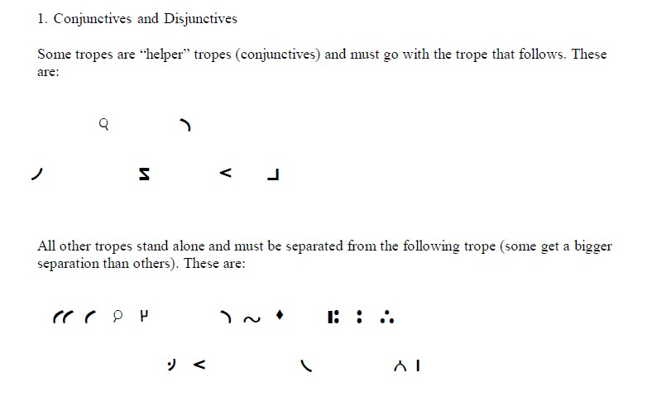

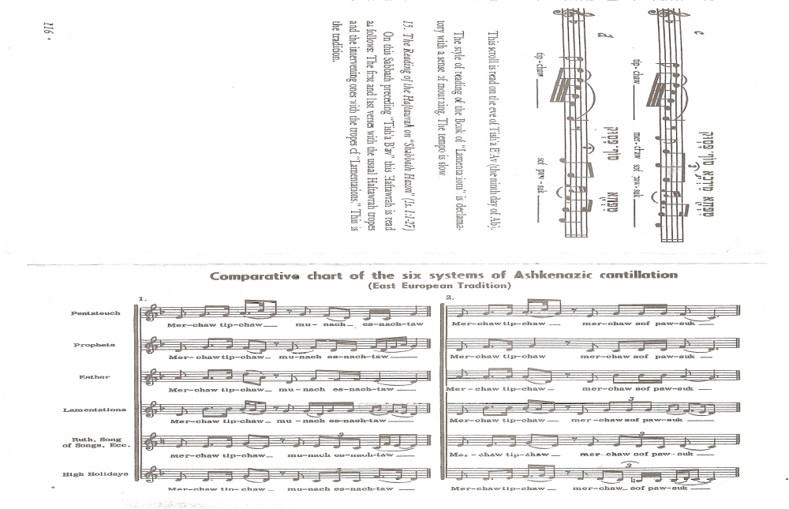

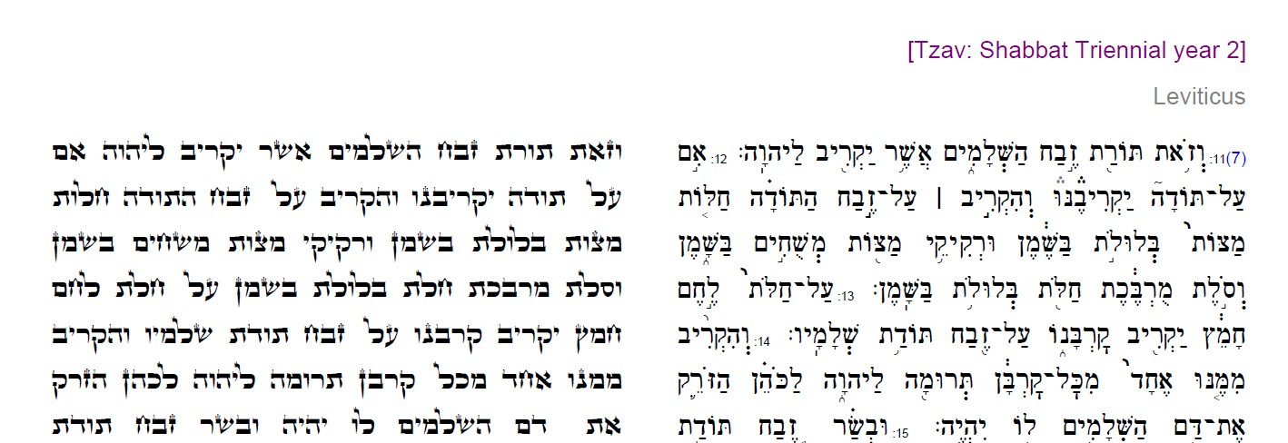

Torah-like Masoretic Text

Nusah

Meaning

Jewish musicologists have devoted great effort to defining nusah as it relates to the musical delivery of the liturgy. Mark Slobin, in Chosen Voices, presents an interesting assortment of views on the meaning of nusah: “The nusach is the cement that holds the service together.” “These melodies and musical modes which have become our nusach, the ‘traditional’ music of the synagogue, were scrupulously adhered to (quoting Wohlberg).” In short, nusah hatefillah is the way the prayer service is chanted: the collection of appropriate modes, motifs and melodies which accompany the liturgical text.

Rather than attempt an exhaustive and rigorous definition of the term “mode”, we will use the simple description of a mode as the combination of a set of notes (such as a scale) and a set of musical motifs (or small melodies). The set of notes may be complex, such that the sequence of notes in successive octaves are unique, or that the set of notes in an ascending use differ from the notes in a descending use (e.g. a melodic minor scale). The musical motifs may be as simple as a three-note pattern, or as complex as twenty or more notes, with or without rhythmic indications. However, it is important to remember that modes are generally more complicated than scales. A scale can be used as a surrogate for a mode only when the motifs are just not that well-defined.

The music of the High Holy Days utilizes five modes which are unique, at least in name, to Jewish prayer, and two scales which are surrogates for the modes. The set of tones which constitute each mode are clear, but the motifs which accompany the tones are more complex. The reader is referred to the following resources for a description of the motifs for each mode:

Cohon, B. 1950. The Structure of the Synagogue Prayer-Chant. Journal of the American Musicological Society 3/1:13-32.
Avenary, H. 1971. The Concept of Mode in European Synagogue Chant. Yuval 2:11-21.
Davidson, C. 1996. Immunim Be-Nusah Ha-Tefillah. Ashbourne Music Pub. Elkins Park, PA.
Levine, J. 1989. Synagogue Song in America. White Cliffs Media Co. Crown Point.
Idelsohn, A. 1929. Jewish Music in Its Historical Development. Holt and Co. New York.

The following descriptions of the scale tones are presented here only to avoid confusion between the modes. However, these are not complete descriptions of the modes, since such a description requires the presentation of accompanying motifs.

Adonai Malakh:

The tones constituting the Adonai Malakh mode are similar to the major scale, but with a lowered 7th degree and, in extension, a lowered 10th. Used in the Malkhuyot and Shofarot sections in the liturgy.

Magen Avot:

The scale tones of Magen Avot match those of a natural minor scale (the “aeolian” mode, or the scale on the 6th degree). Use in the shaharit service.

Ahavah Rabba:

The tones of the Ahavah Rabba mode are similar to those of a harmonic minor beginning on its 5th scale degree. However, below the tonic, the 6th is raised, and above the octave the 10th is lowered. Found in numerous places in the liturgy.

Selihah:

The scale tones of the selihah mode are identical with those of the minor scale (harmonic). Variations within the mode also include raised 4th and 6th scale degrees (known as the Ukrainian-Dorian hexachord). Used in many places in the High Holy Day liturgy, including the Amidah, Avinu Malkeinu, and (as expected) Selihot.

Weekday Amidah (pentatonic):

The tones of the weekday Amidah are (approximately) the scale composed of successive major seconds and minor thirds. (e.g. C-D-F-G-A-C). This is used for the Rosh HaShanah minha Amidah when it occurs on a weekday.

Major:

The major scale in Western music is composed of the pattern of the following intervals: 1-1-1/2-1-1-1-1/2. While all of the modes include some modulation to the major scale, it is sometimes used as a surrogate for Adonai Malakh.

Minor:

The minor scale has a number of variations in Western music, but always begins with the pattern of intervals:
1-1/2-1-1. The “natural” minor continues with the pattern 1/2-1, while the “dorian” minor continues with 1-1/2. The harmonic minor has a raised 7th degree.

An appropriate description for chanting a particular prayer would include the mode. Within a given mode there are an infinite number of melodic, harmonic, and rhythmic possibilities. However, in many cases the proper chanting of a prayer – the proper nusah – is more specific. There may be a specific melody for the text, or there may be a set of motifs that function as a paradigm for numerous texts. In the High Holy Day liturgy, for example, the musical motifs used for the chanting of the rishut “misod hakhamim…” are used for other texts with little variation. Thus, we see that motivic material can be used as indicators for a mode (possibilities) or as constraints on the melodic line.

Sources

The sources for the nusah are as varied as the hazzanim who brought the music from Europe. The following are common resources for identifying the nusah for the High Holy Days:

- Composition anthologies

Anthologies of notated music have been created which seek to bring together the most common traditions for chanting the services. The best examples of these anthologies are

Baal Tefilah, Abraham Baer, compiled in 1877, with both eastern and western European nusah.
Cantorial Anthology, Gershon Ephros, 1923, combines compositions found in Baer with more recent recitatives and choral arrangements
Jewish Songbook, Abraham Idelsohn, 1938, but printed in 1951. A collection of pieces which include both recitatives and choral arrangements.
Shir leShelomoh, Aron Friedmann, published in the 1920s, presents nusah for the complete year for Eastern European Askenazim.

Examples:
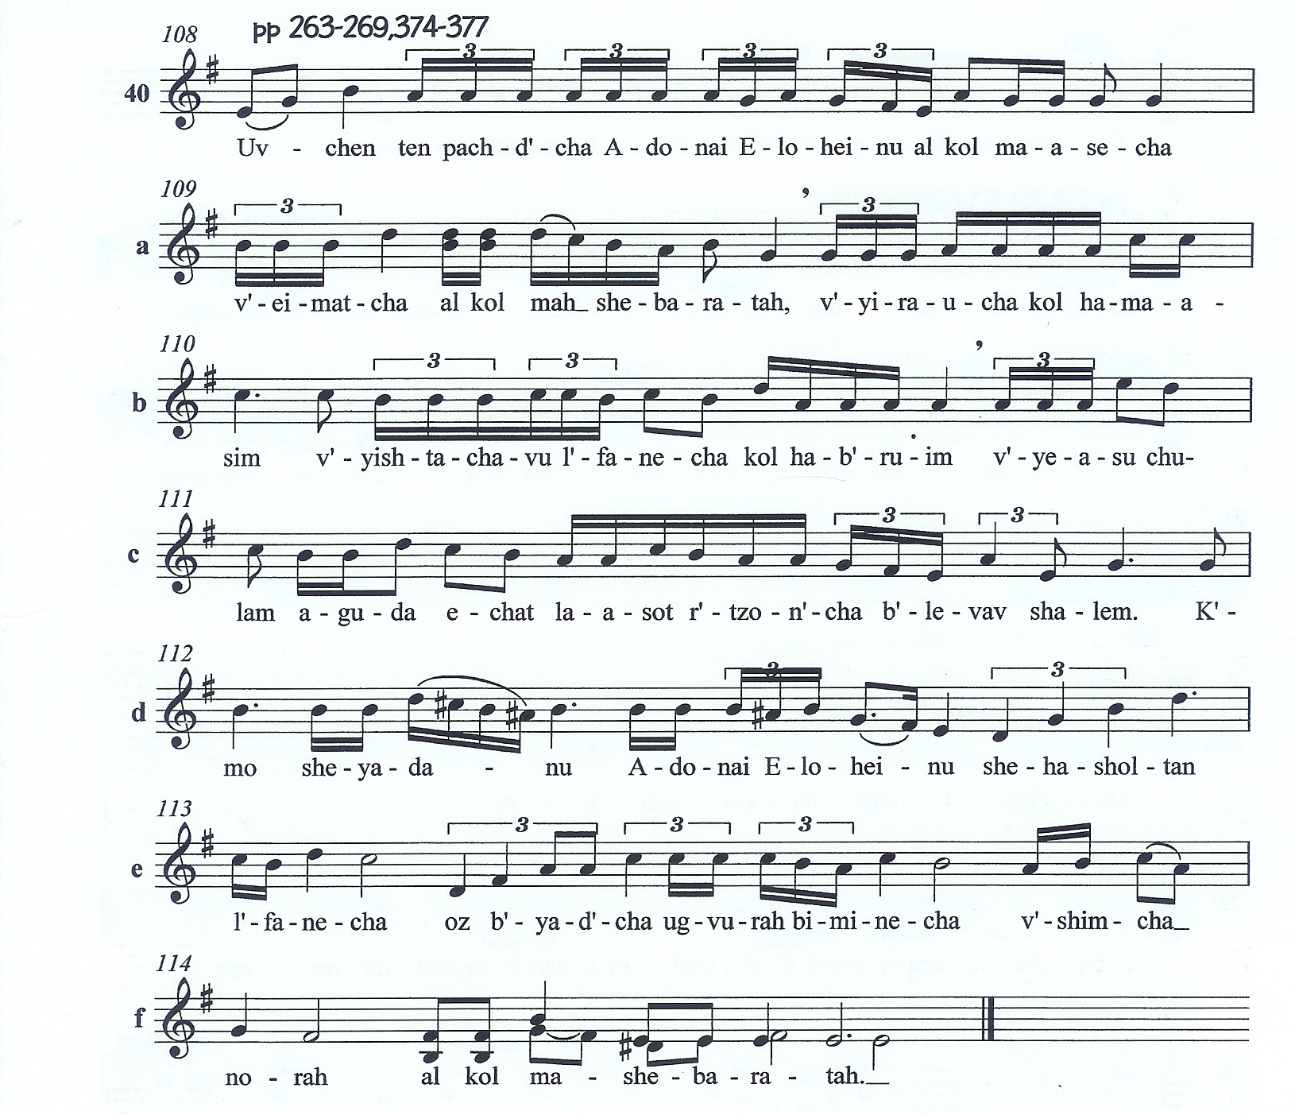
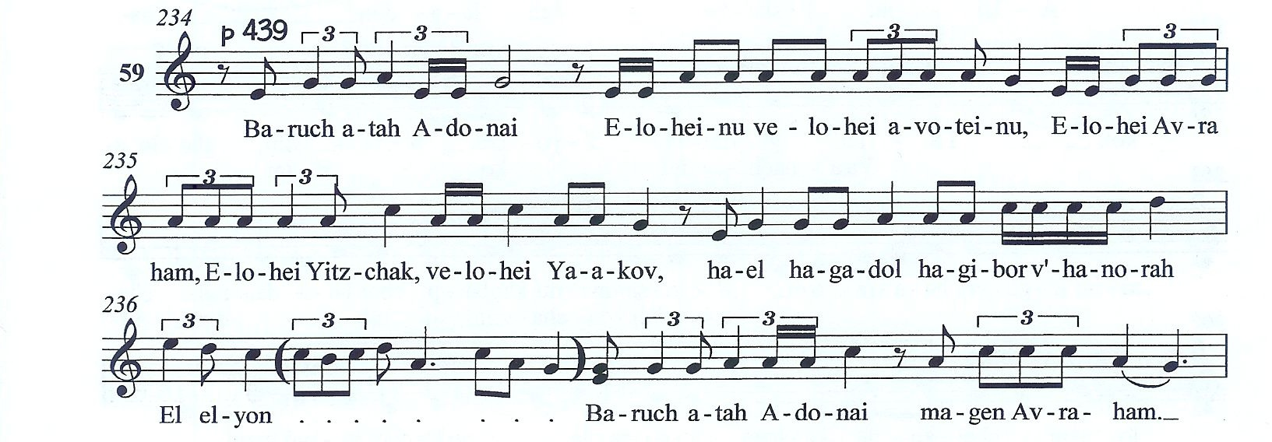

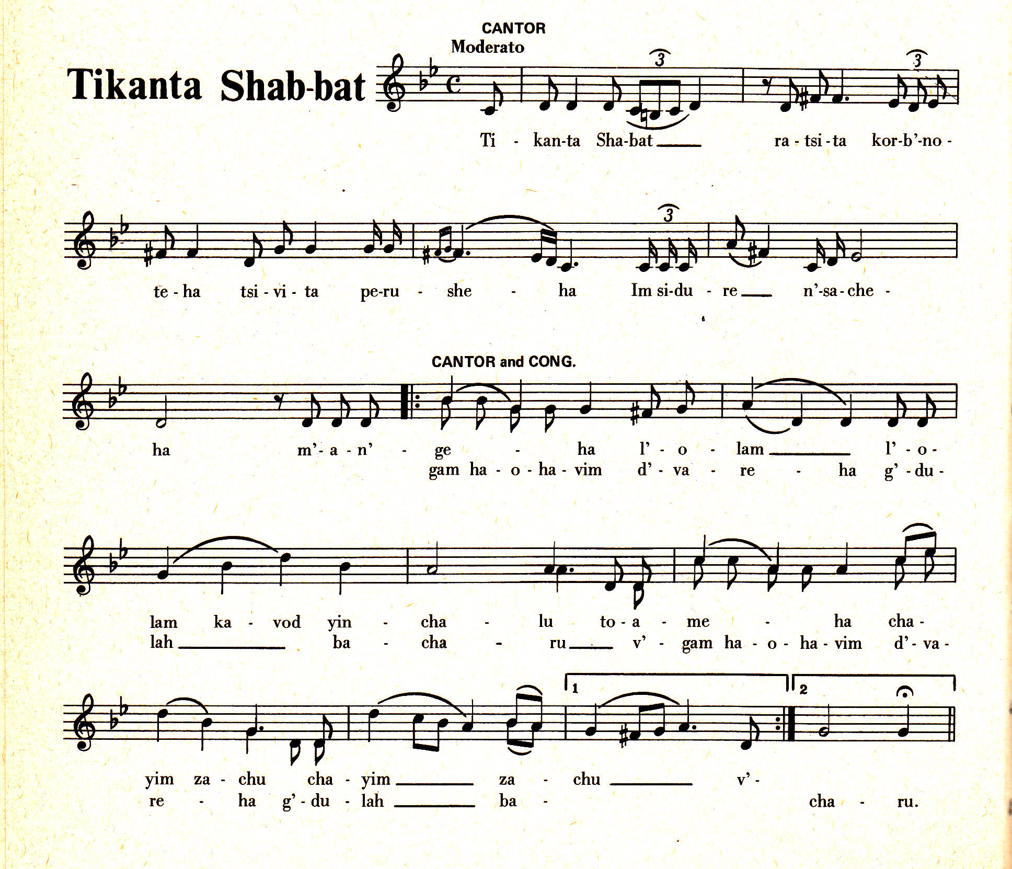
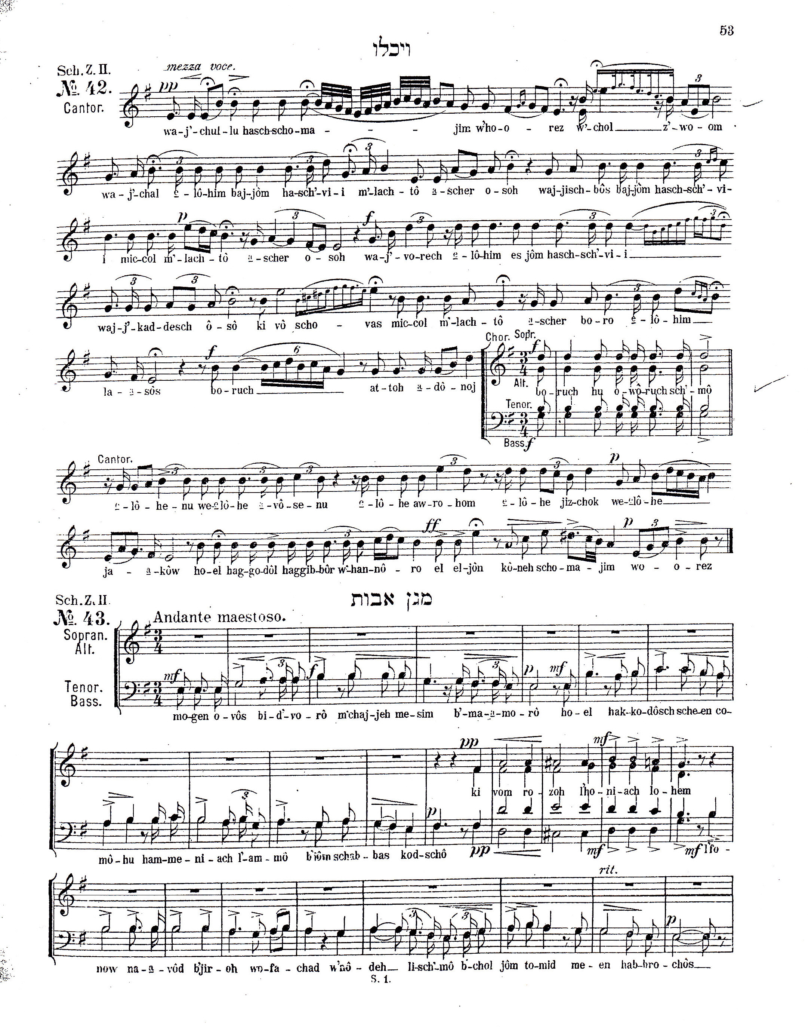

Slobin, M. Chosen Voices. Univ. of Illinois Press. Urbana. 2002. P.257.

